Click or tap here to enter text.

**TERM :**

| **Course & Section Code:** | **COMP214** |
| --- | --- |
| **Course Name:** | **Advanced Database Concept** |
|  |  |
| **Q&A / Virtual Office Hour:** |  |
| **Instructor Name & Email:** | Ersan Cam  [ecam@my.centennialcollege.ca](mailto:ecam@my.centennialcollege.ca) |

Assigment#3 _Version2

(Database Programming Fundamentals)

**Due Date :**

Instructions for delivery of this Labs file back to instructor.

**Step 1:** Download this word copy of Lab document.

**Step2:** Work on your question in SQL Developer.

**Step3:** Once you solve the problem copy paste the code under each question and Highlight with RED color

**Step4:** Also go to your Sql Developer and capture screen entire screen with command you execute and result at the bottom. Use Snipping tool in windows to capture screen shot. Below picture shows how to open free windows based snipping screen capture tool

Step5: Drop your finalized & saved word document to respective Lab dropbox assignment folder.

**Please note that Instructor has the right to call out any students randomly to ask demonstration their solution and walk thru their work and justify their answers in one on one breakout room.**

**The tool to capture screen shot.**

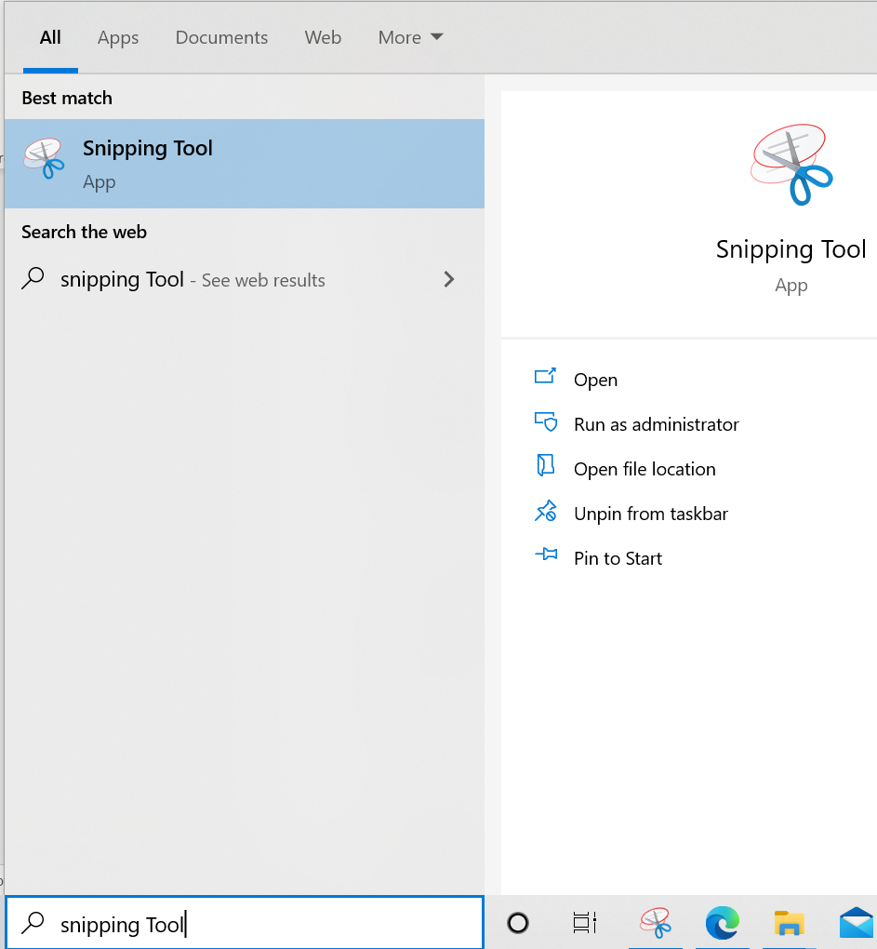

**Demo Question:** How to execute Sequence.Nextval command?

Demo Answer:

Copy paste of actual command: SELECT std_seq.NEXTVAL FROM DUAL;

Demo Screen shot:

Copy paste screen shot of same command

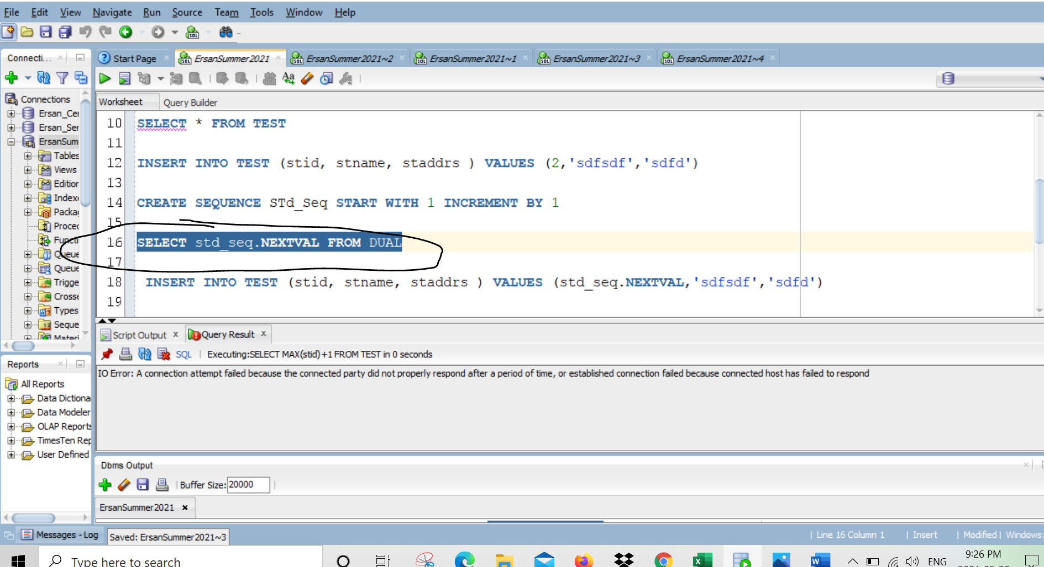

**Total 4 questions, each 25 points, Total 100**

**Solve Question 1 by working with OT_XXX database**

1. **Data processing with COMPISITE variables**

1-a) Create High level Flowchart of below problem before you solve it with IF statement

You can use draw.io (https://app.diagrams.net/) free online flow chart diagram tool or draw basic flow on a paper and take a picture and attach image to this same word document

1-b) The OT company wants to display a rating value for customer’s orders for each product

The rating assignments are outlined in the following table:

Develop a SQL statement to find total amount per each product_id and load this result to a cursor

Hint:

In the OT_ORDER_ITEMS table group by based on Product_id and calculate TOTAL amount ( formula SUM(quantity*unit_price) group by product_id)

Hint for the query:

SELECT product_id, SUM(quantity*unit_price) FROM table

GROUP ….

….

Go thru this result with CURSOR FOR LOOP and determine each record by assigning category code

If

**N**

|  |  |
| --- | --- |
| **Total amount** | **Category** |
| Between 100,000 and 300,000 | Low |
| Between 300,001 and 700,000 | Mid low |
| Between 700,001 and 999,999 | Mid High |
| Greater than or equal to 1,000,000 | Extreme High |
|  |  |

PL/SQL code has to print each Product_id, total amount and then also category code for each record

**Product Id total**

1 292932.43 Low

2 585092.71 Mid Low

3 117598.53 Low

4 1190695.59 Extreme High

***………………***

***Explain whole logic that you use in this program and explain your reasoning***

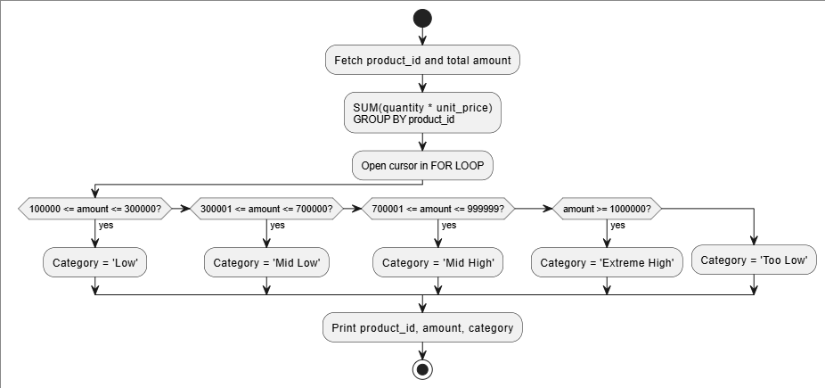

DECLARE

CURSOR c_orderCat IS

SELECT oi.product_id, SUM(oi.unit_price * quantity) as total

FROM OT_ORDER_ITEMS oi

JOIN OT_PRODUCTS p ON oi.product_id = p.product_id

GROUP BY oi.product_id;

v_category VARCHAR(20);

BEGIN

DBMS_OUTPUT.PUT_LINE(RPAD('Product Id', 12) || ' ' || RPAD('Total',12) || ' ' || RPAD('Category', 15));

FOR rec_orderCat in c_orderCat LOOP

IF rec_orderCat.total BETWEEN 100000 AND 300000 THEN

v_category := 'Low';

ELSIF rec_orderCat.total BETWEEN 300001 AND 700000 THEN

v_category := 'Mid Low';

ELSIF rec_orderCat.total BETWEEN 700001 AND 999999 THEN

v_category := 'Mid High';

ELSIF rec_orderCat.total >= 1000000 THEN

v_category := 'Extreme High';

ELSE

v_category := 'Too low';

END IF;

DBMS_OUTPUT.PUT_LINE(

RPAD(rec_orderCat.product_id, 12) || ' ' ||

RPAD(rec_orderCat.total, 12) || ' ' ||

RPAD(v_category, 15)

);

END LOOP;

END;

I declared and assigned a cursor to the product_id and total of the order items and product tables. I also declared a scalar variable, v_category to hold the to-be outputted category for the row. I printed table headers at the top of the execution section to make the successive DBMS output (the informational rows) make more sense. The *total* column of each record/ row of when the for loop iterates through the cursor will be tested in the IF ELSIF … ELSE structure and assign v_category. Then, each row gets printed out with the category.

**2. Using Nested IF Statements ( Main IF will have another IF THEN ELSE as nested (child-Inner) inside)**

An organization has committed to matching pledge amounts based on the donor type and

pledge amount. Donor types include I = Individual, B = Business organization, and G = Grant

funds. The matching percents are to be applied as follows:

**Donor**

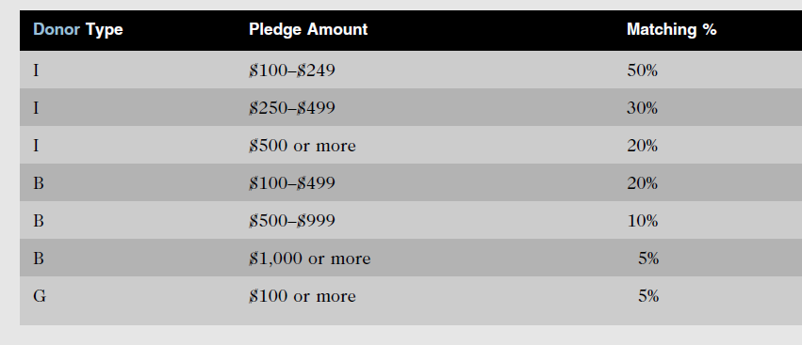

Create a PL/SQL block using nested IF statements to accomplish the task. Input values for

the block are the donor type code and the pledge amount.

***Explain whole logic that you use in this program and explain your reasoning***

ACCEPT donorType CHAR PROMPT 'Enter donor type (I/B/G): '

ACCEPT pledgeAmount NUMBER PROMPT 'Enter pledge amount: '

DECLARE

v_donorType CHAR(1) := '&donorType';

v_donorTypeFull VARCHAR2(30);

v_pledgeAmt NUMBER := &pledgeAmount;

v_matching NUMBER;

v_total NUMBER;

BEGIN

IF v_donorType = 'I' THEN

v_donorTypeFull := 'Individual';

IF v_pledgeAmt BETWEEN 100 AND 249 THEN

v_matching := 0.5;

ELSIF v_pledgeAmt BETWEEN 250 AND 499 THEN

v_matching := 0.3;

ELSIF v_pledgeAmt >= 500 THEN

v_matching := 0.2;

ELSE

-- 0, not one of the options

v_matching := 0;

END IF;

ELSIF v_donorType = 'B' THEN

v_donorTypeFull := 'Business';

IF v_pledgeAmt BETWEEN 100 AND 499 THEN

v_matching := 0.2;

ELSIF v_pledgeAmt BETWEEN 500 AND 999 THEN

v_matching := 0.1;

ELSIF v_pledgeAmt >= 1000 THEN

v_matching := 0.05;

ELSE

-- 0, not one of the options

v_matching := 0;

END IF;

ELSIF v_donorType = 'G' THEN

v_donorTypeFull := 'Grant funds';

IF v_pledgeAmt >= 100 THEN

v_matching := 0.05;

ELSE

-- 0, not one of the options

v_matching := 0;

END IF;

ELSE

-- invalid type

DBMS_OUTPUT.PUT_LINE(v_donorType || ' is an invalid Donor Type.');

END IF;

IF v_matching = 0 THEN

DBMS_OUTPUT.PUT_LINE(v_pledgeAmt || ' is too low.');

ELSIF v_donorType IN ('I', 'B', 'G') THEN

DBMS_OUTPUT.PUT_LINE('Donor Type of (' || v_donorType || ')' || v_donorTypeFull || ' for $' || v_pledgeAmt);

DBMS_OUTPUT.PUT_LINE('The organization is matching ' || v_matching * 100 || '% ($' || v_pledgeAmt * v_matching || ') ');

v_total := v_pledgeAmt + (v_pledgeAmt * v_matching);

DBMS_OUTPUT.PUT_LINE('Total donation is $' || v_total);

END IF;  
END;  
  
  
  
I added in some ACCEPT PROMPT statements to make the prompts more understandable.

I then gave v_donorType a CHAR(1) type as that is the most the donorType is supposed to need.

The v_donorTypeFull variable is to hold the eventual full donor type name.

The v_pledgeAmt holds the number given by the user from the prompt.

The v_matching will hold the percentage, in decimal format, for usage in printing and for calculating the donor match.

The v_total is a variable to hold the calculate total, pledgeAmt + donor match amount.

In the execution block I start the first IF ELSIF … ELSE structure. I chose to test the donorType first as it is a more concise method to test 3 options that have varying inner outcomes (the pledge amount tests are different).

I assign the donorTypeFull to the respective title and test the pledgeAmt on each of the donorType’s cases.

I assign v_matching to 0 in each ELSE, default, case to use later for printing out that the input was too low.

The ELSE statement for the outer loop will also print that it was an invalid donor type.

At the end, in the last IF structure, I test v_matching on if it is 0 as a 0 v_matching variable means that the pledgeAmt was too low and in the case that v_matching was not 0 and the donorType is I, B, or G, do the calculations and printing out of information.

Multiplying the v_matching by 100 gets us the percentage value of the v_matching decimal.

And to get total, I added the pledgeAmt with the pledgeAmt multiplied by the v_matching decimal.

**Use OT_XXX Database for Question 3**

**3. Procedure to find Product sales total amount and product name**

Develop a stored procedure named **sp_product_total** to return total amount and product name.

This procedure will accept 2 Input parameters… order_id and product_id same as IT_ORDER_ITEMS

Then in the begin and end , procedure will first find total amount for this order_id and product id by multiplying quantity * unit_price

Then also by using either JOIN or subquery techniques, procedure will have to find product name in OT_PRODUCTS table for a given product_id

And procedure will have to return two values back to caller… total and product name

***Explain whole logic that you use in this program and explain your reasoning***

*===============================================================*

CREATE OR REPLACE PROCEDURE SP_PRODUCT_TOTAL (

order_id IN OT_ORDER_ITEMS.order_id%TYPE,

product_id IN OT_ORDER_ITEMS.product_id%TYPE,

v_total OUT NUMBER,

v_product_name OUT VARCHAR2

)

AS

BEGIN

SELECT SUM(oi.quantity * oi.unit_price), p.product_name

INTO v_total, v_product_name

FROM OT_ORDER_ITEMS oi

JOIN OT_PRODUCTS p ON oi.product_id = p.product_id

WHERE oi.order_id = SP_PRODUCT_TOTAL.order_id

AND oi.product_id = SP_PRODUCT_TOTAL.product_id

GROUP BY p.product_name;

END SP_PRODUCT_TOTAL;

I created the input variables order_id and product_id and then two output variables to return information from the procedure, v_total and v_product_name.

In the execution block, I wrote a select statement to return the total and product name.

I used a JOIN on product_id instead of a subquery because I thought it was a more concise solution.

The oi_order_id had to equal the input variable order_id and the oi.product_id had to equal the input variable product_id. Due to the fact that order_id is a column on the OT_ORDER_ITEMS table and product_id being a column on both OT_ORDER_ITEMS and OT_PRODUCTS, I had to specify that the variables were from SP_PRODUCT_TOTAL scope.

VARIABLE v_total VARCHAR2(100)

VARIABLE v_product_name VARCHAR2(100)

EXEC sp_product_total(70, 32, :v_total, :v_product_name)

PRINT v_total

PRINT v_product_name  
  
I then created two variables and executed the procedure with 70 as the order_id and 32 as the product_id

Once the procedure finishes running, the total and product name gets printed out.

**Use LGXXXX Database for Question 4**

**Use LG_LargeCo_ORA.txt scripts under Assignment3 folder to build necessary tables**

**4- Function to find max invoice amount**

Develop a function named **fn_finding_max_invoiceamount** with two input and one return value.

This function will accept one parameter p_employee_id same as LGINVOICE and then

In BEGIN and END it will select all the invoice records belong to this particular employee.

Then among all these invoice details your function has to find max INV_TOTAL of all and return this value to caller program.

You can use simple MAX function to find among all invoices belong to this employee , or use array and sort them and find max , or use Cursor and process records to find max of all. I am OK any of these methods.

Let’s assume function takes parameter p_employee_id as 83734 . It has to return 496.38 as max invoice amount of all entries for this employee

Test the function with different employee and share the screen shots

***Explain whole logic that you use in this program and explain your reasoning***